Open Claw setup

npm –version
Install below 2 line code openclaw logo will appear
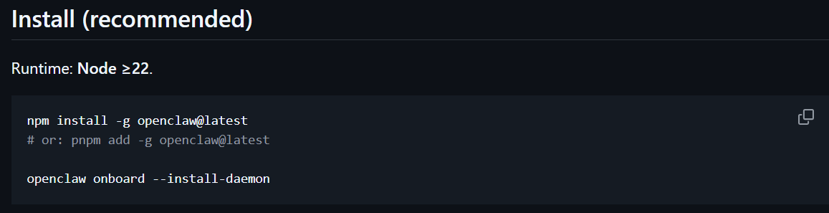
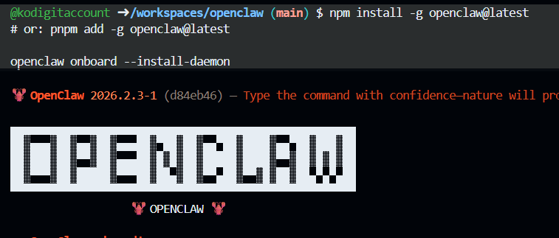
Select below to yes on boarding mode quick start integration to LLM model
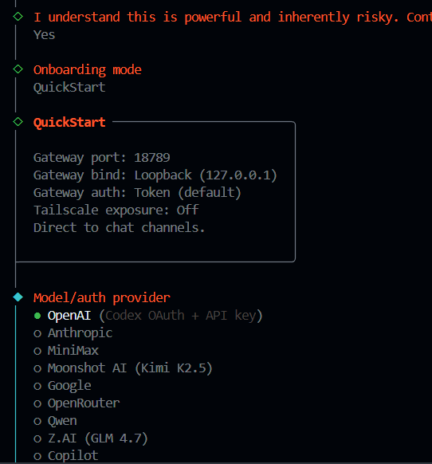
Select openrouter copy key select model connect to telegram
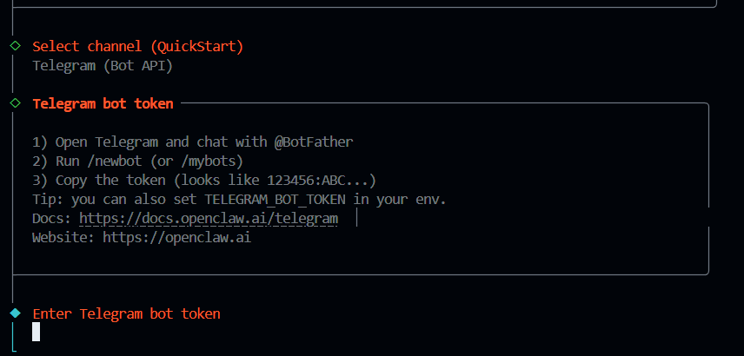
Mount telegram from mobile to computer telegram account search with @botfather below is the screen you will appear
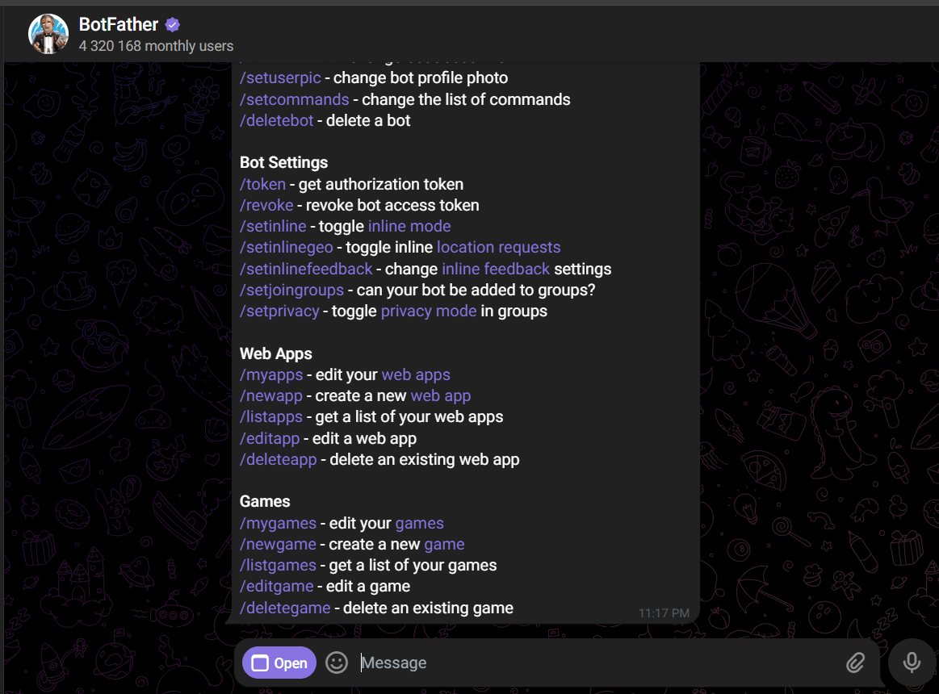
Run the /newbot command create display name kodi bot 5 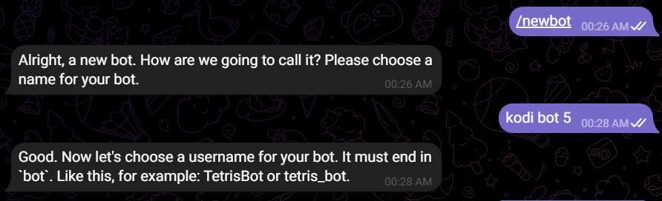
Message saying a user name must ends with _bot . that’s why need to give user name as kodibot5_bot
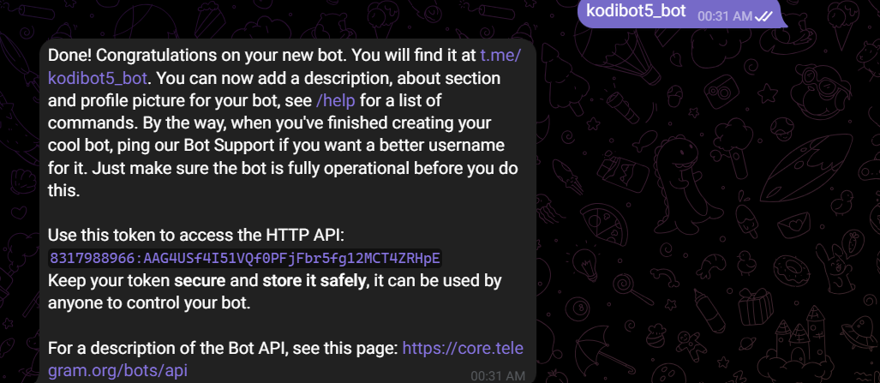
Copy the token paste in openclaw terminal keep asking few option just skip them and at the end user will receive message as on boarding will complete.
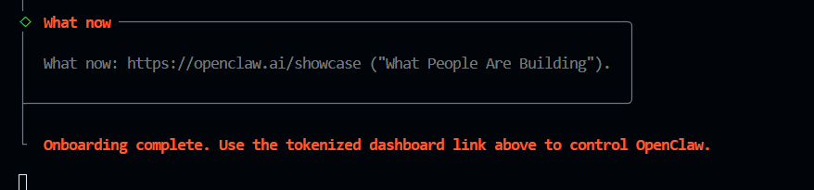
Finally we create telegram bot
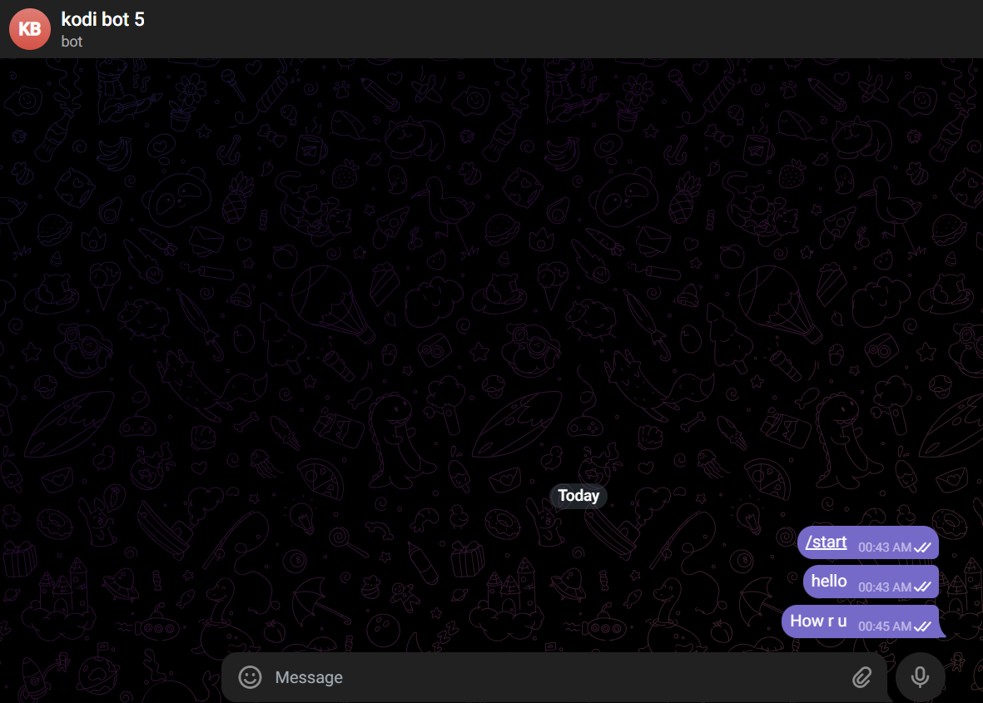
=================================================================================

From openclaw website user need to copy below code & after paste user might get below error iwr & iex command not found
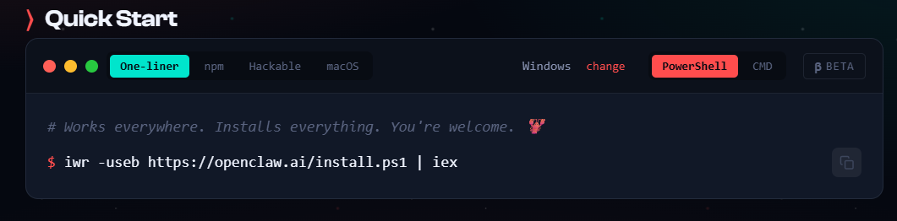
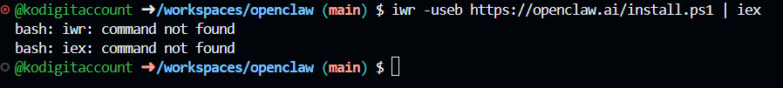
If you get error then use – pnpm install
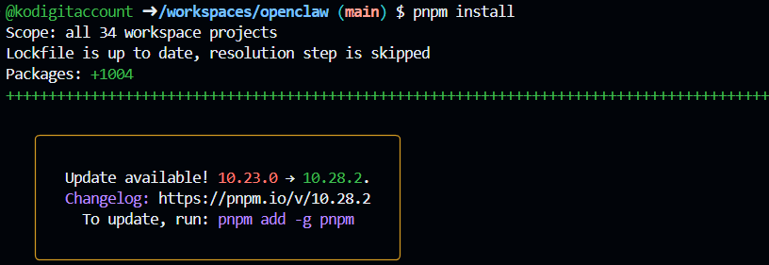
Next step is to use pnpm ui:build
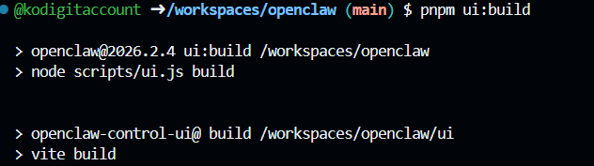
Next step pnpm build
